Kenya

## Respect for rule of law (ROL) data

The data set shows the data on the respect of the rule of law for the country.

## # A tibble: 19 x 5  
## country iso3c date ruleOfLaw ruleOfLawCategory4   
## <chr> <chr> <dbl> <dbl> <chr>   
## 1 Kenya KEN 1996 -1.02 ROL highly disrespected   
## 2 Kenya KEN 1998 -1.05 ROL highly disrespected   
## 3 Kenya KEN 2000 -0.873 ROL moderately disrespected  
## 4 Kenya KEN 2002 -0.874 ROL moderately disrespected  
## 5 Kenya KEN 2003 -0.830 ROL moderately disrespected  
## 6 Kenya KEN 2004 -0.836 ROL moderately disrespected  
## 7 Kenya KEN 2005 -0.882 ROL moderately disrespected  
## 8 Kenya KEN 2006 -0.878 ROL moderately disrespected  
## 9 Kenya KEN 2007 -0.966 ROL moderately disrespected  
## 10 Kenya KEN 2008 -0.994 ROL moderately disrespected  
## 11 Kenya KEN 2009 -1.01 ROL highly disrespected   
## 12 Kenya KEN 2010 -0.942 ROL moderately disrespected  
## 13 Kenya KEN 2011 -0.904 ROL moderately disrespected  
## 14 Kenya KEN 2012 -0.824 ROL moderately disrespected  
## 15 Kenya KEN 2013 -0.711 ROL moderately disrespected  
## 16 Kenya KEN 2014 -0.417 ROL moderately disrespected  
## 17 Kenya KEN 2015 -0.488 ROL moderately disrespected  
## 18 Kenya KEN 2016 -0.441 ROL moderately disrespected  
## 19 Kenya KEN 2017 -0.413 ROL moderately disrespected

## Respect for rule of law (ROL) trend

The plot shows the trend of the respect for the rule of law for the country.

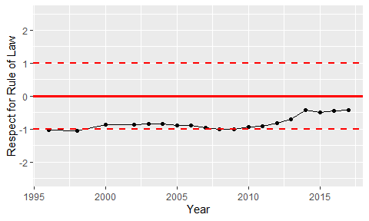

Trend of the Respect for the Rule of Law